**Lab-2**

**Objective:**

* The objective of this lab is to learn how to use queries for different types of condition.

Table Creation

CREATE DATABASE Bank_DB;

CREATE TABLE The_customer_relation(Customer_name varchar(30), Customer_street varchar(10), Customer_city varchar(20));

INSERT into the_customer_relation VALUES('Adams','Spring','Pittsfield');

INSERT into the_customer_relation VALUES('Brooks','Senator','Brooklyn');

INSERT into the_customer_relation VALUES('Curry','North','Rye');

INSERT into the_customer_relation VALUES ('Glenn','Sand Hill','Woodside');

INSERT into the_customer_relation VALUES('Green','Walnut','Stamford');

INSERT into the_customer_relation VALUES('Hayes','Main','Harrison');

INSERT into the_customer_relation VALUES('Johnson','Alma','Palo Alto');

INSERT into the_customer_relation VALUES('Jones','Main','Harrison');

INSERT into the_customer_relation VALUES('Lindsay','Park','Pittsfield');

INSERT into the_customer_relation VALUES('Smith','North','Rye');

INSERT into the_customer_relation VALUES('Turner','Putnam','Stamford');

INSERT into the_customer_relation VALUES('Williams','Nassau','Princeton');

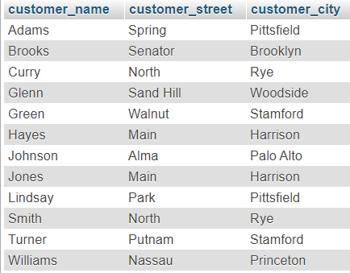

Fig: Table-1

CREATE TABLE The_loan_relation(loan_number varchar(10), branch_name varchar(30), amount int(7));

INSERT into the_loan_relation VALUES('L-11','Round Hill',900);

INSERT into the_loan_relation VALUES('L-14','Downtown',1500);

INSERT into the_loan_relation VALUES('L-15','Perryridge',1500);

INSERT into the_loan_relation VALUES('L-16','Perryridge',1300);

INSERT into the_loan_relation VALUES('L-17','Downtown',1000);

INSERT into the_loan_relation VALUES('L-23','Redwood',2000);

INSERT into the_loan_relation VALUES('L-93','Mianus',500);

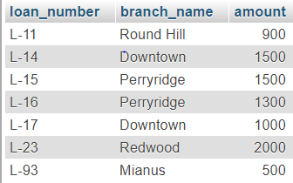

Fig: Table-2

CREATE TABLE Account(account_number varchar(10), branch_name varchar(30), balance int(7));

INSERT into account VALUES('A-101',' Downtown', 500);

INSERT into account VALUES('A-102',' Perryridge', 400);

INSERT into account VALUES('A-201',' Brighton', 900);

INSERT into account VALUES('A-215',' Mianus', 700);

INSERT into account VALUES('A-217',' Brighton', 750);

INSERT into account VALUES('A-222',' Redwood', 700);

INSERT into account VALUES('A-305',' Round Hill', 350);

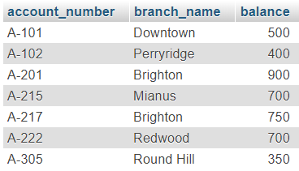

Fig: Table-3

1. The names of all branches in the “loan” relation:

SELECT branch_name FROM `the_loan_relation`;

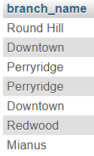

1. All the loan numbers for loans made at the “Perryridge” branch with loan amounts greater than 300:

SELECT Loan_number FROM the_loan_relation WHERE Branch_name='Perryridge' AND Amount>300;

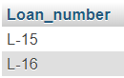

1. All the loan numbers of the customers who has loan either “Perryridge” branch or “Downtown” branch:

SELECT Loan_number FROM the_loan_relation WHERE Branch_name='Perryridge' OR Branch_name='Downtown';

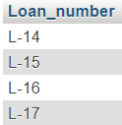

1. All the loan numbers of the customers who has loan either “Perryridge” branch or “Downtown” branch or “Mianus”branch:

SELECT Loan_number FROM `the_loan_relation` WHERE Branch_name IN('Perryridge', 'Downtown', 'Mianus');

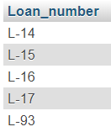

1. The names of all customers who are not from “Stamford” or “Princeton” or”Harrison”:

SELECT Customer_name FROM `the_customer_relation` WHERE customer_city NOT IN('Stamford', 'Princeton', 'Harrison');

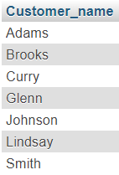

1. The maximum , minimum and average account balance in the “Account” relation:

SELECT MAX(balance), Min(balance), AVG(balance) FROM `account`;



To see in the full form:

SELECT MAX(balance)"Maximum balance", Min(balance)"Minimum balance",

AVG(balance)"Average balance" FROM `account`;



1. The total number of customer from “Customer” relation:

SELECT COUNT (Customer_name) FROM the_customer_relation;



1. The loan number of those loans with loan amounts between 400 and 800:

SELECT loan_number FROM `the_loan_relation` WHERE amount>= 400 AND amount<=800;



1. The names of all customes whose name start with”G”:

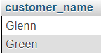

1. The names of all customers whose name ends with”s”:

SELECT customer_name FROM `the_customer_relation` WHERE customer_name LIKE "%s";

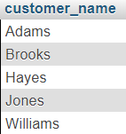

1. The names of all customers whose name has a “o”in 2nd position:

SELECT customer_name FROM `the_customer_relation` WHERE customer_name LIKE "_o%";

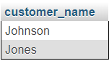

Name consist with one "a":

SELECT customer_name FROM `the_customer_relation` WHERE customer_name

LIKE "%a%";

